**RTI TESTING REPORT**

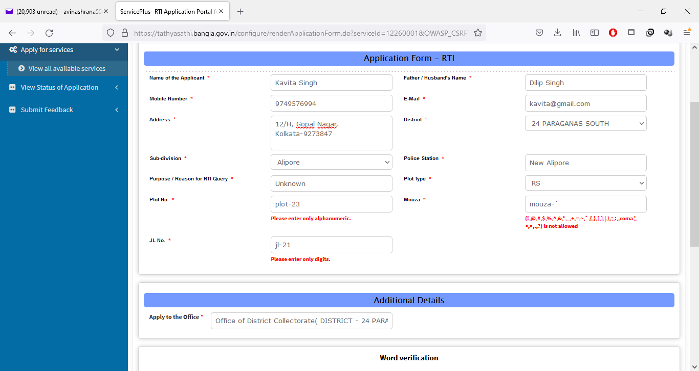

Mouza is taking characters only

Plot no not taking hyphen(-)and other required special character

Jl No. is taking only numbers

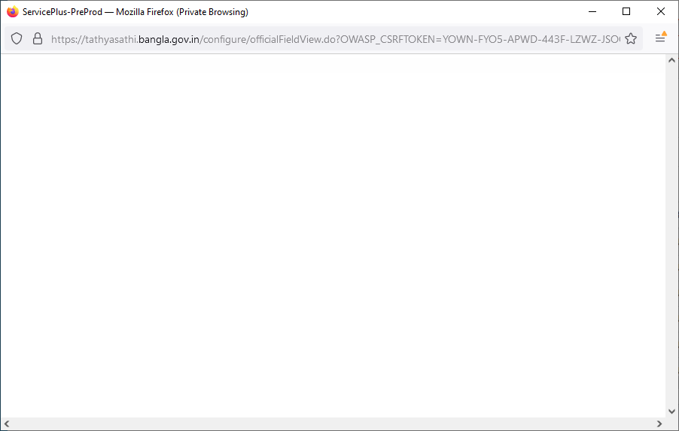

SPIO cannot view action details of Surveyor check LA Status

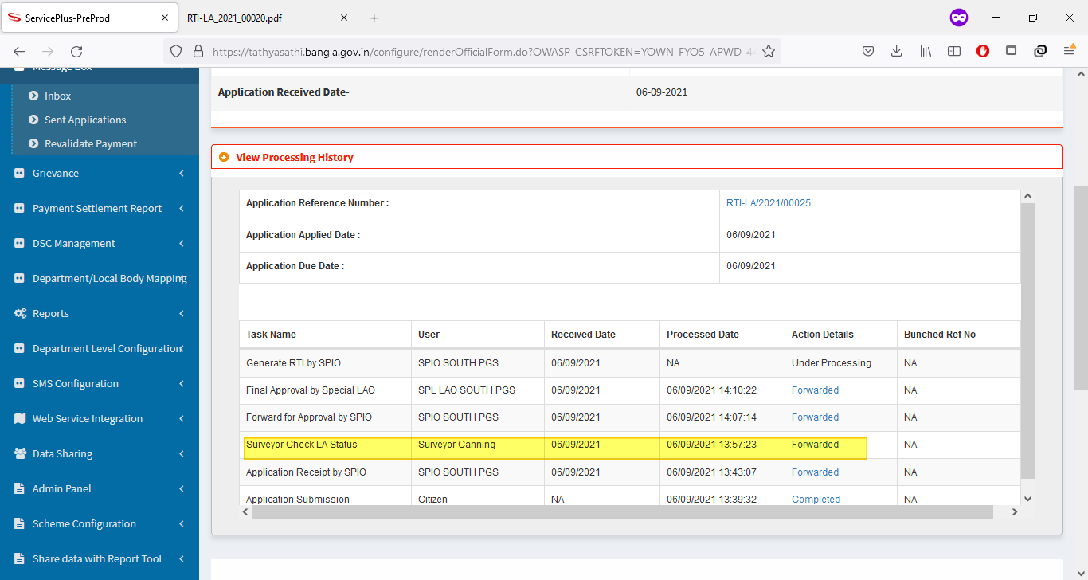

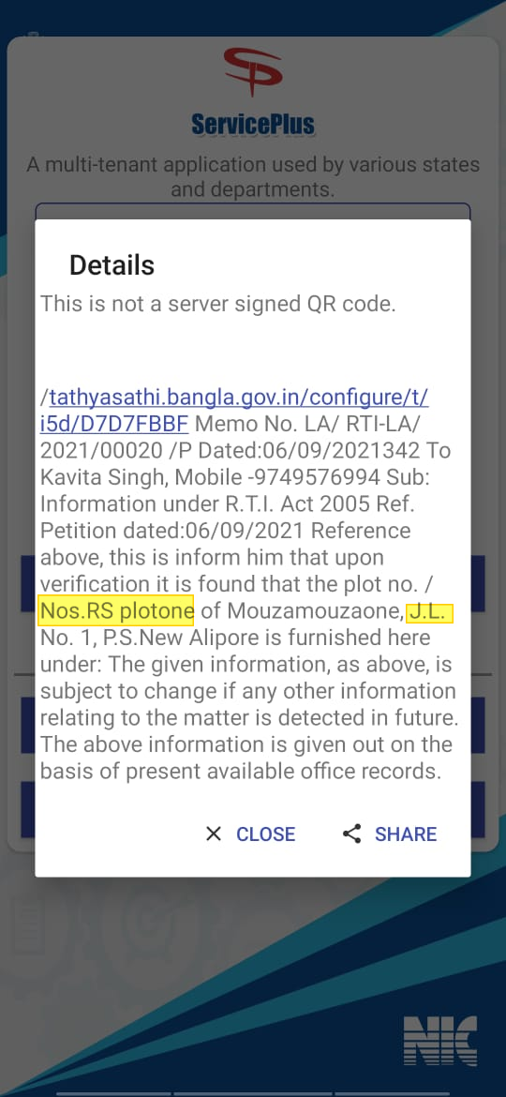

Label plot , mouza and jl should be separated by hyphen(-) or colon(:)